**FALL PHOTO DAY IS COMING!!!**

**STARK ELEMENTARY SCHOOL**

**DATE: THURSDAY SEPTEMBER 21, 2023**

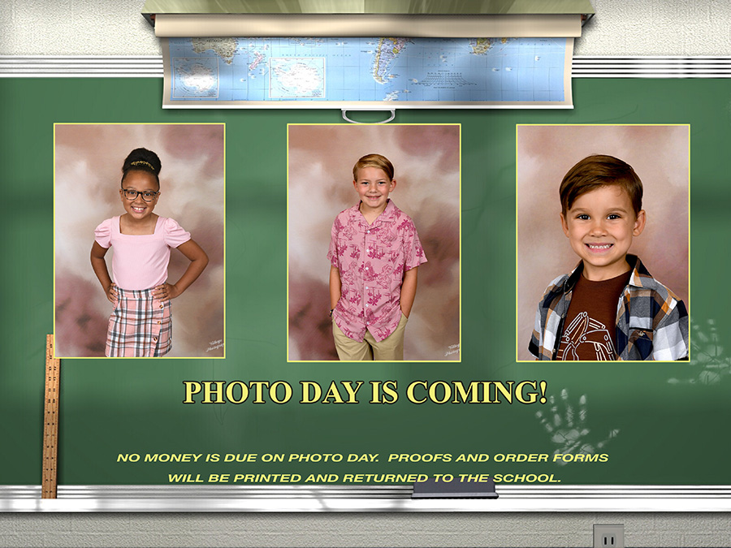

**• No pre-ordering is necessary**

**• Once, photos have been taken you will receive an order form with your child’s proofs printed on it. Multiple poses will be printed of each child. The proof sheet/order form will be distributed to each student to bring home within a week of photo day.**

**• Cash and Credit Cards accepted. Make checks payable to: Village Photography.**

**• Return your completed order form to the school by the Due Date indicated above the proofs.**

**• All orders will be shipped back to the school.**

**• If you have any questions please feel free to call Village Photography at 678-359-1365 Mon – Fri 9am - 4pm**

**or email us at** [**orders@villagephotography.com**](mailto:orders@villagephotography.com)

**• Product Info and a coupon on how to qualify for FREE photos is on the Proof Sheet/Order Form.**

**• To order after the due date, please contact our office Mon-Fri 9am to 5pm. 678-359-1365**