Relationships and the Query Object
Directions: Make sure the FBLA database is open. You will follow the steps below to learn how to create a relationship and queries.
Relationships

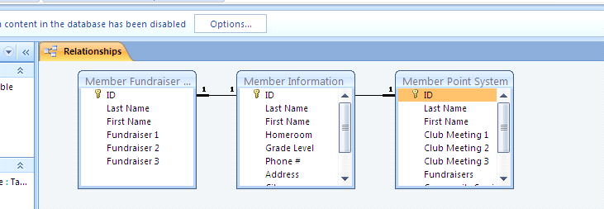
By creating a relationship between the tables, you can create queries using information from each of the different tables. The ID number becomes the foreign key because each member has their own unique ID #.
To create a relationship between the three tables, follow these simple steps:
1. If the Security Warning appears below the Ribbon, Click Options, click the Enable this content option button, then click OK.
2. Click on the Database Tools Tab
3. Choose Relationships
4. This creates a relationship between the three tables with the ID as the foreign key
5. To add any tables to the relationship, you would need to choose Edit Relationships and Create New – the left table name is the Primary table – the right table name is the related table - the left column name and the right column name must be the foreign key – in this database, the ID is the foreign key

Simple Query

1. We will first create a Simple Query using the Query Wizard.
2.
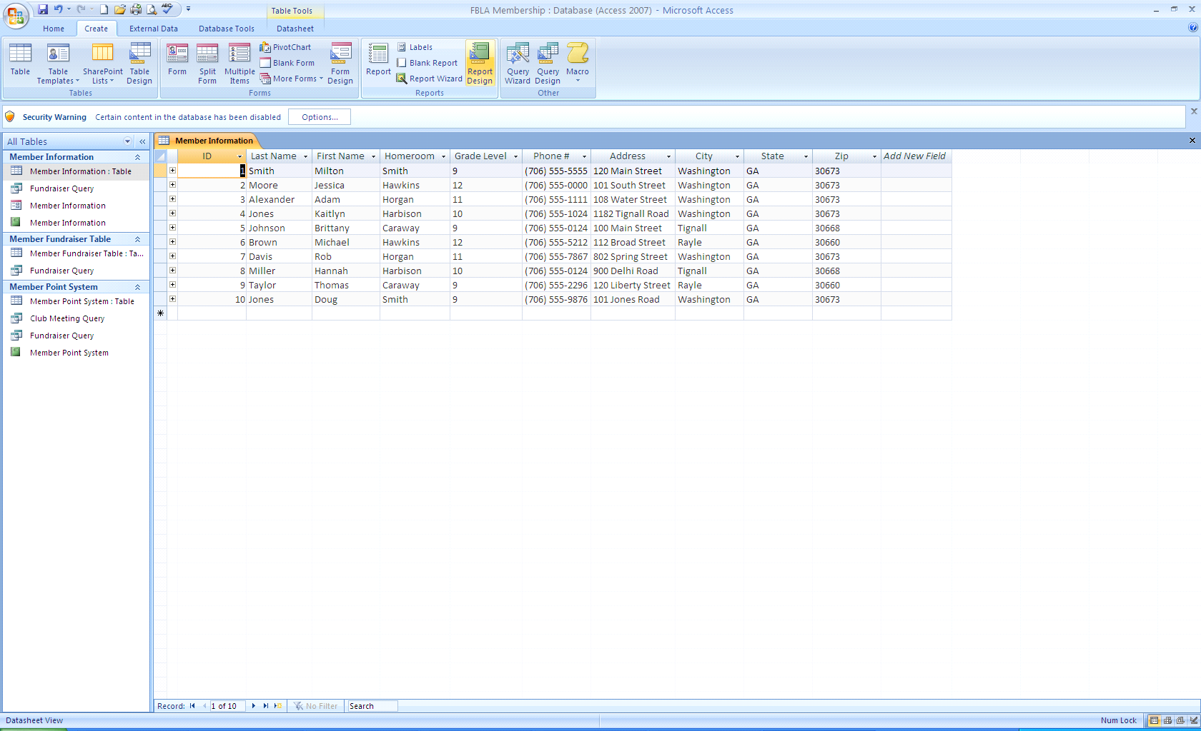
Click on the Create Tab and Choose the Query Wizard command in the Other section
3. Choose Simple Query Wizard
4. In the Tables/Queries section, choose the Member Point System table
5. The Selectable fields are fields you want to display in your query
6. You can move any Available fields to the Selectable fields section by pressing the arrows or double-clicking.
7. In this query, we need a list of students and the club meetings points they earned - include the following fields as your available fields:
a. First Name
b. Last Name
c. Club Meeting 1
d. Club Meeting 2
e. Club Meeting 3
8. Choose Next, choose a detail query, Next
9. Name it Club Meeting Query

Creating a Multi-table Query in Design View
1. We will create a query in Design View next.
2. Click the Create Tab and the Query Design button
3. In this query, we need a list of students, their phone number, their homeroom teacher, and fundraiser points
4.
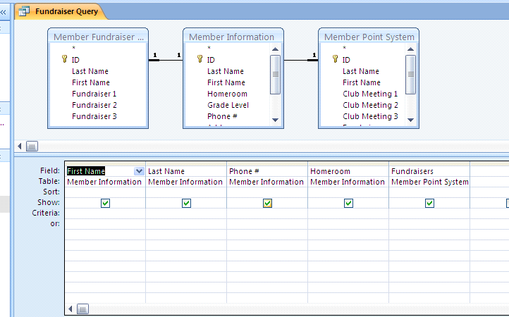
You will need to get information from the Member Information Table and the Point System Table – choose Add to include each table in the query. Then, in the Design grid, do the following:
a. In column 1, choose the Member Information Table and the first name field
b. In column 2, choose the Member Information Table and the last name field; sort in ascending order
c. In column 3, choose the Member Information Table and the phone number field
d. In column 4, choose the Member Information Table and the homeroom field
e.
In column 5, choose the Member Point System Table and the fundraiser field
f. Click the Run button
g. Close the query and name it Fundraiser Points Query
Creating a Query with Calculated Fields
1. You need a query totaling each members fundraisers, you will create a query with calculated fields
2. Click the Create Tab and choose the Query Design button
3. Click the Member Fundraiser Table and Add – then, Close
4. Double-click the following fields to add to the design grid:
a. First Name
b. Last Name
c. Fundraiser 1
d. Fundraiser 2
e. Fundraiser 3
5. In the Field box to the right of Fundraiser 3, right-click and choose zoom
6. In the Zoom Box, type: [Fundraiser 1]+[Fundraiser 2]+[Fundraiser 3] * Use the square brackets to enclose your field names – type the field names exactly as they appear in your database – do NOT space before or after the + sign
7. Click OK
8. Click save and save it as Fundraiser Totals
9. Click Run
10. This will result in a Table with the Totals – notice that the field name of the Totals Column is Expr1
11. Click on the Design View button
12. In the calculated field, double-click Expr1. Do NOT select the colon or any other text in the Field box
13. Type Fundraiser Total and press the TAB key
14. Save and run the query.

