Spreadsheet Fundamentals – Spreadsheet Screen
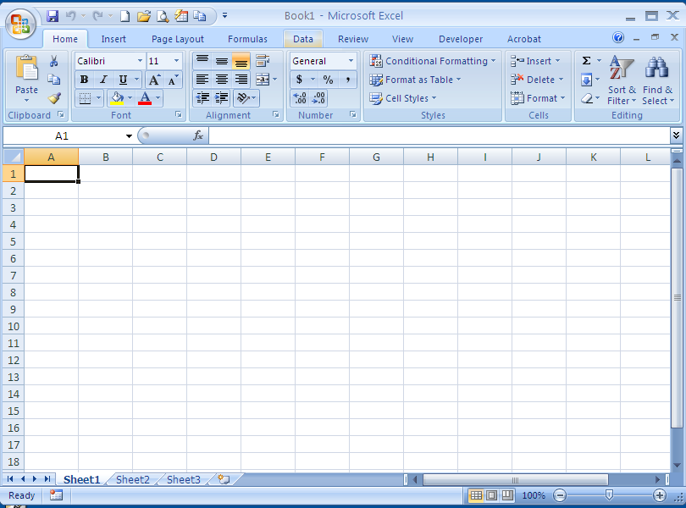
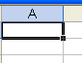
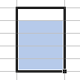
Can You Identify Each Term on the Screen?
active cell
row
column
cell
autosum
Cell address – A1
workbook
36
value
Cost
label
spreadsheet
Sheet tab
=B4*c4
formula
gridlines
sheet
99256
Numeric label
range
K5
K6
K7
K8
K9
K10
K11
Fill handle
selecting
Terms:

Range Label
Fill Handle Spreadsheet
Active Cell Formula
Grid lines Value
Auto format work book
Sheet selecting
Numeric label cell
Graph column
Sheet tab auto sum
Row cell address
Study this handout to prepare for a test on identifying parts of the spreadsheet screen. Know the name of each part and where it is located.

