Windows Movie Maker Basics

Step 1
Get 8 pictures and some music and save them to your user drive.

Open Windows Movie Maker
- Start, Programs, Accessories, Windows Movie Maker
* Location of program may vary by machine

Step 2
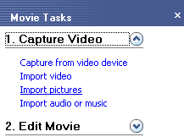
Import Pictures
- Under “Capture Video”, click Import Pictures
- Browse to the folder where your pictures are
- Click the picture you want to import or hold down the Control key to click multiple pictures
- Click Import
- Repeat steps a.-d. if you have pictures in other folders

Step 3
Add Your Pictures to the Storyboard
- Click and drag the pictures onto the Storyboard, preferably in the order you would like them to appear
- To move a picture simply click and drag it to another location on the Storyboard

Step 4
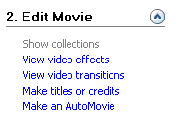
Add Titles and Credits
- Under “Edit Movie” click Make titles or credits
- Choose where you want to add the title
  - At the beginning
  - Before the selected clip
  - On the selected clip
  - After the selected clip
  - Credits at the end
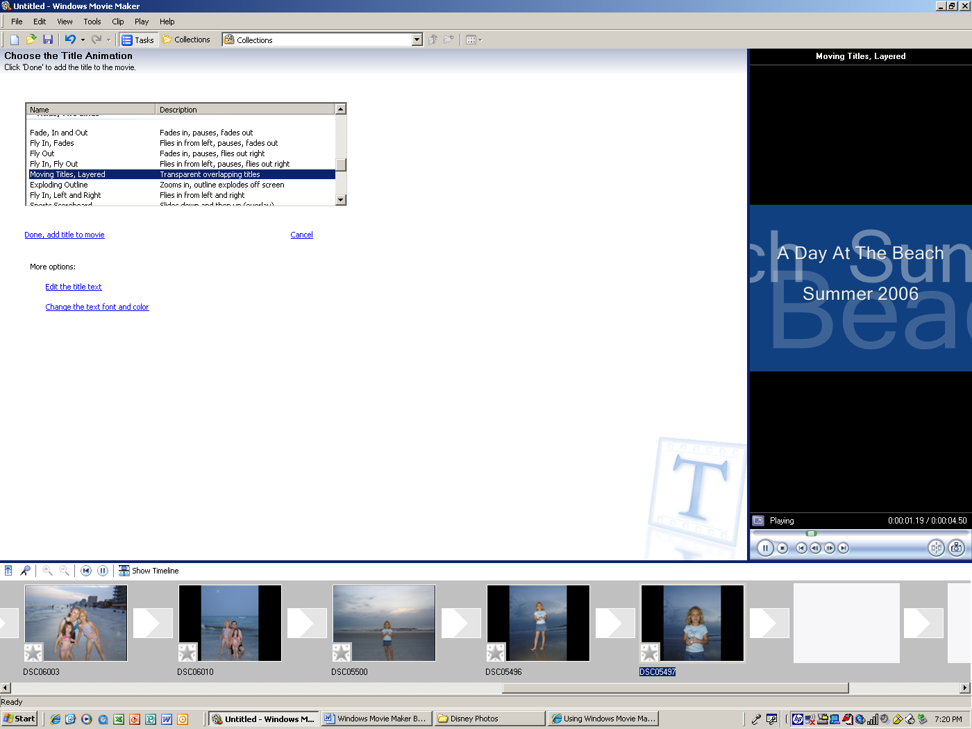
- Click Change the title animation
  - Choose an effect

  - Click Play in the Preview Pane to view the effect again
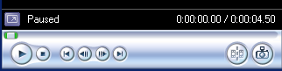

  - Click Change the text and font color
  - Click Done
- Repeat steps a.-c. to add additional titles or credits

Step 5
Add Transitions
- Under “Edit Movie” click View video transitions
- The Collections pane changes to the Video Transitions
pane
- Double click on a transition to see how it looks in the preview window
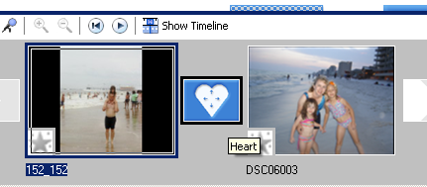
- Drag the transition to the video transition cell
between two pictures on the Storyboard
- Repeat steps c.-d. for each transition cell

Step 6
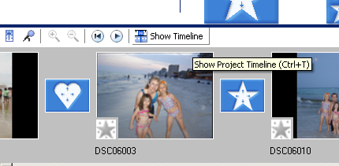
Adjust the Timeline
- Click Show Timeline above the Storyboard

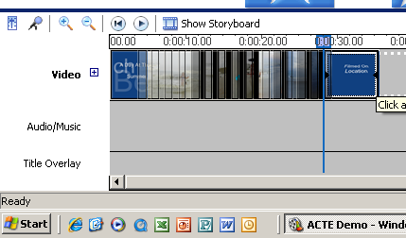
- Click on a picture on the timeline
- Move the pointer over the edge of the picture until it
becomes a red arrow
- Drag the pictures border to the right to make it
longer or the left to make it shorter

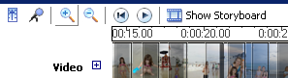
- To zoom in on the timeline, click the magnifying glass

Step 7
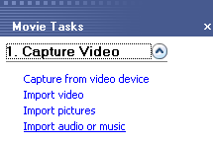
Add Sound
- Under “Capture Video” click Import Audio or Music
- Browse to the folder where your audio file is located
- Click the audio file you want to import or hold down
the Control key to click multiple audio files
- Click Import
- Repeat steps a.-d. if you have audio files in other folders
- Drag the audio file onto the Audio/Music section of the
timeline
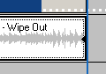
- Click on the audio on the timeline
- Move the pointer over the edge of the audio until it
becomes a red arrow
- Drag the audio border to the left to make it shorter
Step 8
Save Your Video
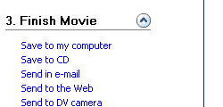
- Under “Finish Movie” click Save to my computer to choose the format for saving
- Enter file name --The file name should be your name 1st video.
- The location of the saved movie should be in your user drive. Browse to your folder and then click NEXT.
- Choose NEXT for Best quality playback. Wait for your movie to be SAVED.
- Click Finish when you have the option.
- Close MOVIE MAKER
Step 9
Preview your Movie
- Open your folder
- You should see your Windows Media Player movie saved in your folder. Play your movie.
- If you are happy with your movie, turn in your movie to be assessed. If you need to make corrections, edit you movie. You will need to save again to FINISH MOVIE.

