Creating the Music and Movies Database
Steps:
- In Access, Choose New on the Office button
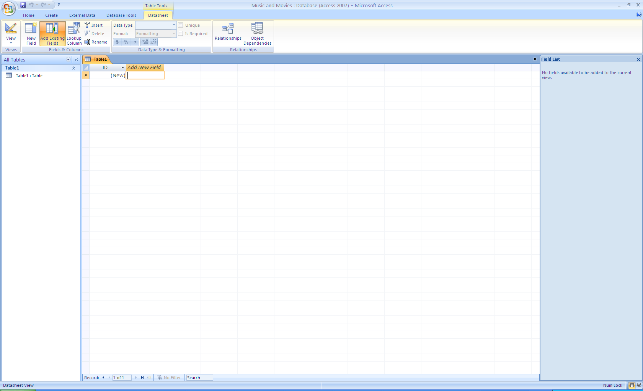
- Save to your Student Folder as Music and Movies
- Double-click on Add New Field and type your first field name-CD Title
- Press Tab to create the rest of your fields:
  - Artist/Band
  - Label
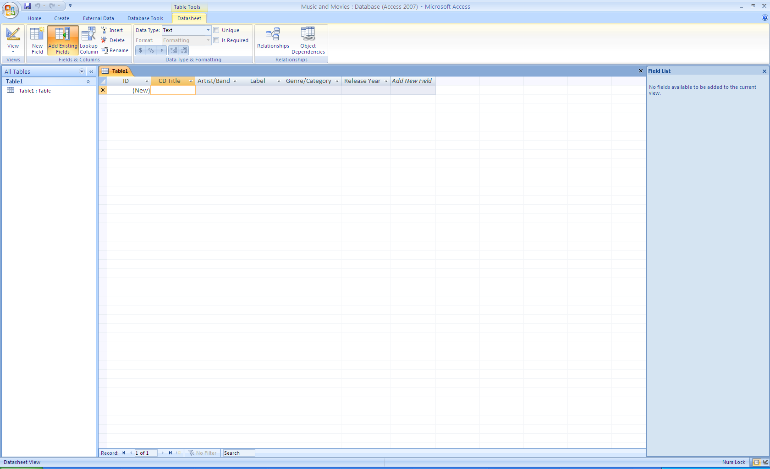
  - Genre/Category
  - Best Price
  - Release Year
- Click on the Design View button and save table as Music
- Change the Genre/Category Data Type to Lookup Wizard and do the following:
  - Select I will type in the values that I want – Next
  - In Col 1 – type every genre/category pressing Tab after each– Next
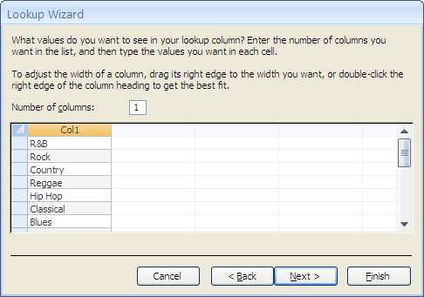
  - Finish
- Change the Best Price Data Type to Currency
- Click on the Datasheet View button
- Type each of the 12 Music records
- In the empty Artist/Band Field – type your name
- Go to the Office Button and Print
- Click on the Create Tab and choose Table
- Double-click on Add New Field and type your first field name-Movie
- Press Tab to create the rest of your fields:
  - Movie
  - Actor/Actress
  - Rating
  - Category
  - Release Year
- Click on the Design View button and save table as Movies
- Change the Rating Data Type to Lookup Wizard and do the following:
  - Select I will type in the values that I want – Next
  - In Col1 – type every rating (G – PG – PG-13 – R NR) pressing Tab after each – Next
  - Finish
- Change the Category Data Type to Lookup Wizard and do the following:
  - Select I will type in the values that I want – Next
  - In Col1 – type every Category ( Classical – Comedy – Family – Drama – Musical and the Arts – Foreign – Horror – Action/Adventure – Other) pressing Tab after each – Next
  - Finish
- Click on the Datasheet View button
- Type each of the 12 Movie records
- In the empty Actor/Actress Field – type your name
- Go to the Office Button and Print

