The Eagles Nest
$FREE

Extra! Extra! Read ALL about it! January 2022 Just the Facts!
Editor: Kaylynn Arnold
Stark Strong!
Special Spotlight  By Brylee Brown    Mr. Bob Merritt  Mr. Bob is a dedicated technology expert here at Stark Elementary. He has been here since 2016. He is quick to respond to fix, adjust, and repair any needs the teachers may have. Mr. Bob works with others in the county to ensure that the safety of everyone isn’t compromised through the use of the internet. Mr.Bob enjoys watching movies with his wife, collecting and repairing antique audio devices, and is a veteran of the air force.  Jackson Weather  Ella Davis - Reporter  It’s going to be a cold month. The high for this month is 57° and the low is 29°. Be sure to grab your jacket! There is not going to be lots of sun, just lots of clouds and rain. Also for once the weather forecast was finally right but of course the snow didn’t stick.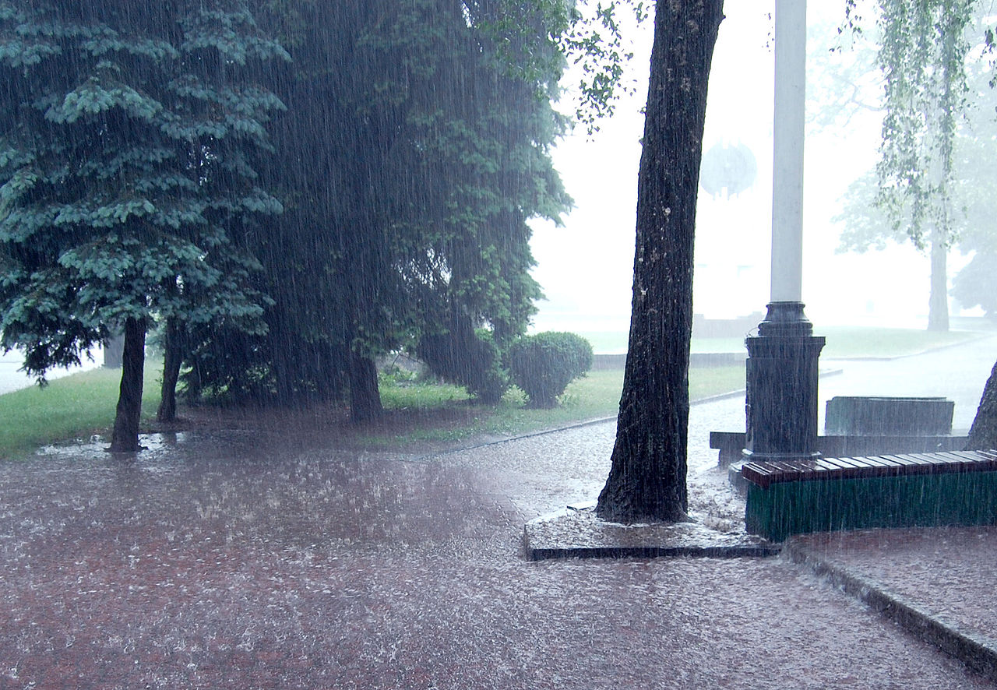  Source  Weather.com  ----------------------------------------------  Fun Facts  Kaylee Kinman - Reporter  - Dolphins sleep with one eye open  - A narwhal's tusk reveals its past living conditions  - Raindrops are shaped more like hamburger buns  - Canada eats more macaroni and cheese than any other nation in the world  - An animal’s yawn based on how large their brain is. The bigger the brain, the longer they will yawn  - Dinosaurs would swallow large rocks which stayed in their stomach to help churn and digest food | Inside News  Abigail Palumbo  Happy Noon Year! First graders celebrated the new year by writing their new year's resolutions and watching the ball drop at 12:00 p.m. This was a cool way to celebrate the new year. Awesome job first grade!  Thank you Ms. Lyons for the great idea!  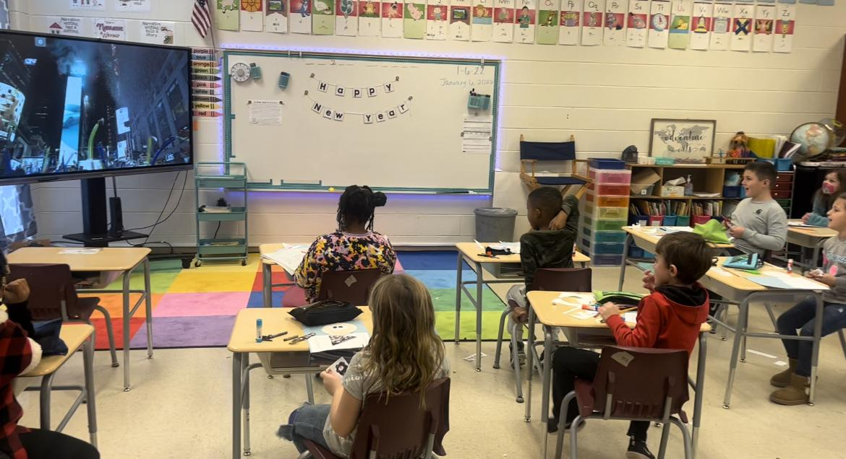  Mrs. Brown's class  100th Day of School  Kaylynn Arnold  The 100th day of school was on Friday, January, 21st. There were many teachers and students that celebrated by dressing up like senior citizens. The teachers integrated the number 100 in all the subjects.  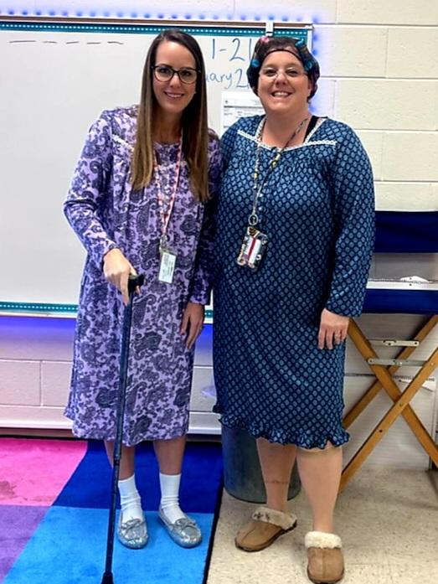  Ms. Dickerson and Ms. Brown   | Sports  Serenity Hughes  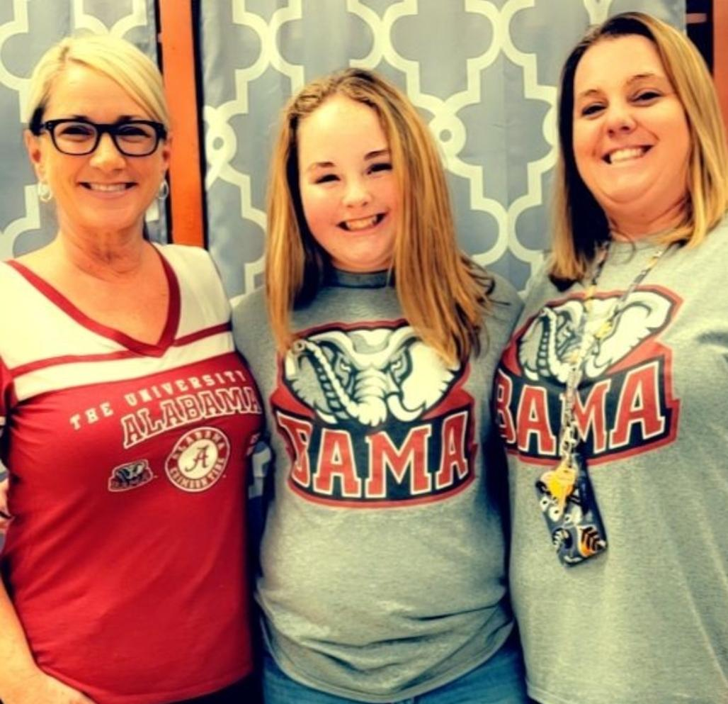  They finally did it! After years of being defeated, the Dawgs came back with a win against Alabama. On Monday, January 10, the Dawgs defeated Alabama 33-18. If you're a Georgia fan you sure have some cheering to do, but if Alabama is your team, so sad for you! Kirby Smart, the Georgia Bulldogs coach, was a former player and led his team to their first title win since 1980.  Recyclable Towers  Ms. Johnson  For the next few weeks, TAG students will be constructing towers/skyscrapers in the Robotics Lab using recyclable materials. The students will be able to experiment, explore, and consider factors such as gravity, weight, and spatial awareness. Please stop by and see their progress as they collaborate to build the best tower!  ---------------------------------------------------  Riddle  Ella Davis - Reporter  Grandpa went for a walk, and it started raining. He forgot to bring an umbrella and didn’t have a hat. When he got home, his clothes were soaking wet, but not the hair on his head. How was this possible?  I am beautiful, up in the sky. I am magical, yet I cannot fly. To people I bring luck, and to some people, riches. The boy at my end does whatever he wishes. What am I?  https://www.rd.com/article/long-riddles/  ---------------------------------------------------  Clubs & Organizations  Band  Chorus  Robotics  Reading Bowl  Girls on the Move  Boys on the Move  Drama Club  Student Council  4H  CHAMPS  Good News Club

