The Eagles Nest
$FREE

Extra! Extra! Read ALL about it! September 2021 Just the Facts!
Editor: Kaylynn Arnold
Stark Strong!
Special Spotlight  By Brylee Brown    Coach Sims  Coach Sims is a hard working educator who cares about everybody. She works heavily with our community and shares her gift of love with everyone. Coach loves seeing kids happy, playing with friends, and family. When students or children in the community need help, she will be on her way to help them. She loves playing cornhole with family and friends on weekends. She also loves dancing and enjoys working in her yard. For these reasons and more, Coach Sims is well deserving to be in the Special Spotlight for our very first newspaper here at Stark Elementary.  -----------------------------------------------  Jackson Weather  Ella Davis  Reporter    Playground  There will be a mixture of rain, wind, and sun this month. 86°F to 77°F is going to be the normal temperature for September. There is a new hurricane named Larry. There will be several hurricanes this month. The hurricanes may not hit us, but we will get some rain.  Source  https://weather.com  -----------------------------------------------  Fun Facts  Kaylee Kinman  Reporter  A single sneeze travels 100 miles per hour and shoots 100,000 germs into the air.  A chef's hat has exactly 100 pleats!  "I Am" is the shortest complete sentence in the English language. | Inside News  By Abigail Palumbo  Last week, September 3rd, 2021 the kindergartners participated in a community service unit. Community service is one of the best ways to teach young students the value of empathy. It can also teach them compassion and selflessness.  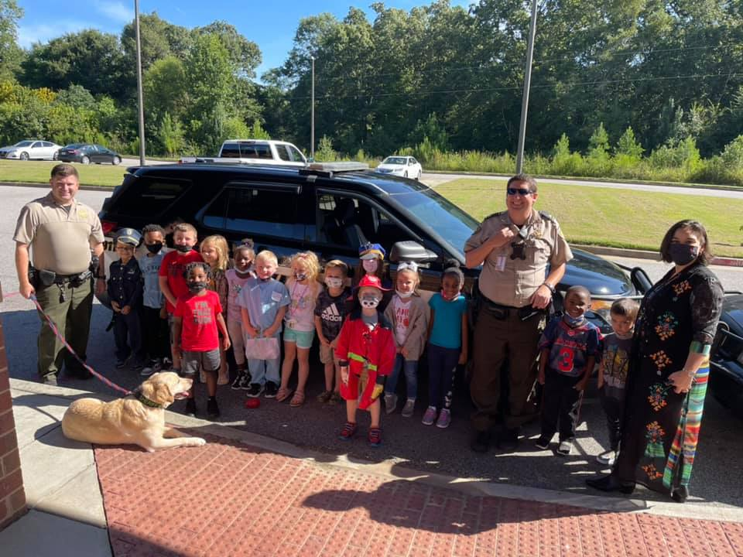  Butts County Sheriff Department  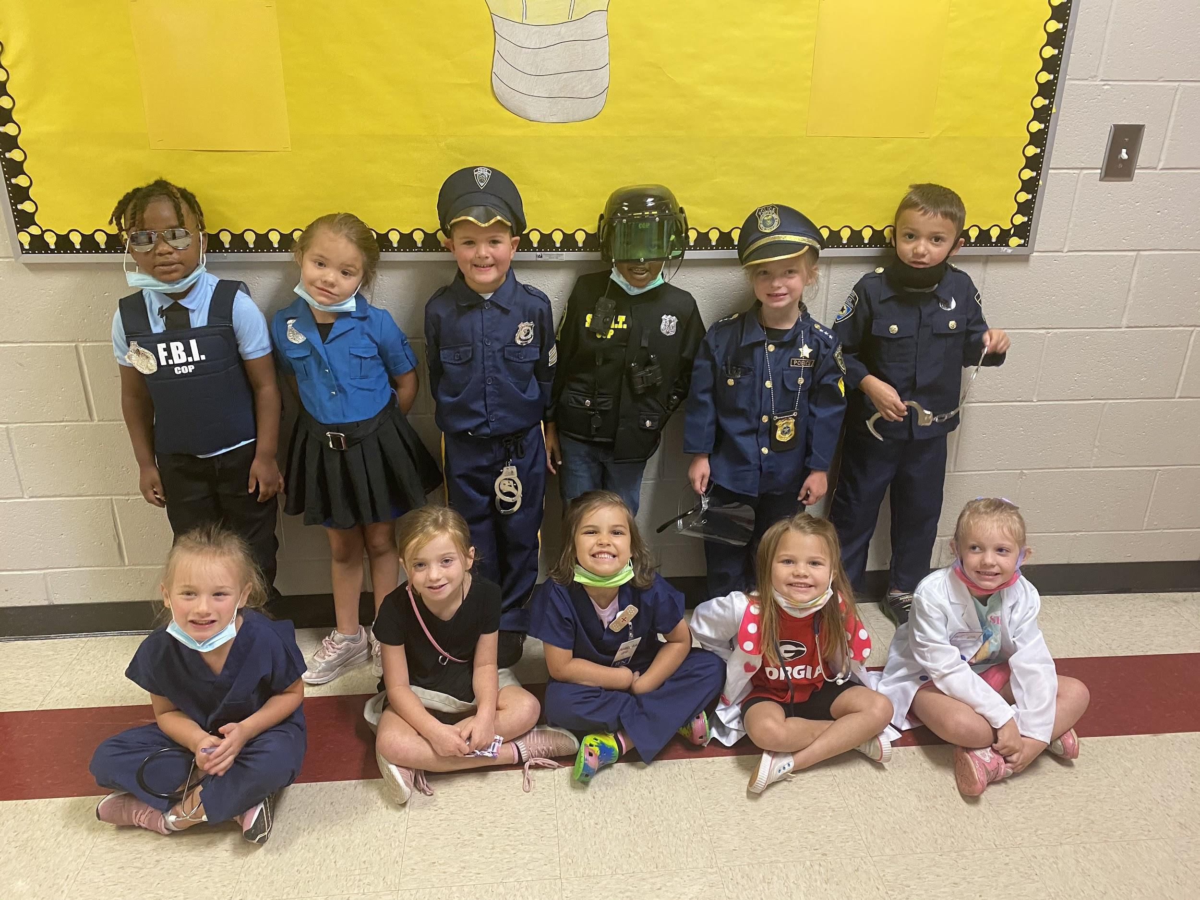  Ms. Ramjohn’s  Community Helpers  Students here at Stark weren’t yet born when two planes struck the World Trade Center in New York City, one cut through the Pentagon outside Washington D.C. and another crashed into a field in Shanksville, Pennsylvania, on Sept. 11, 2001.  Dressed in red, white and blue, students and staff sang songs, made presentations about America’s history, and turned an otherwise somber day into one of unity and hope. We are proud of our school and proud to show our support for Patriots Day!  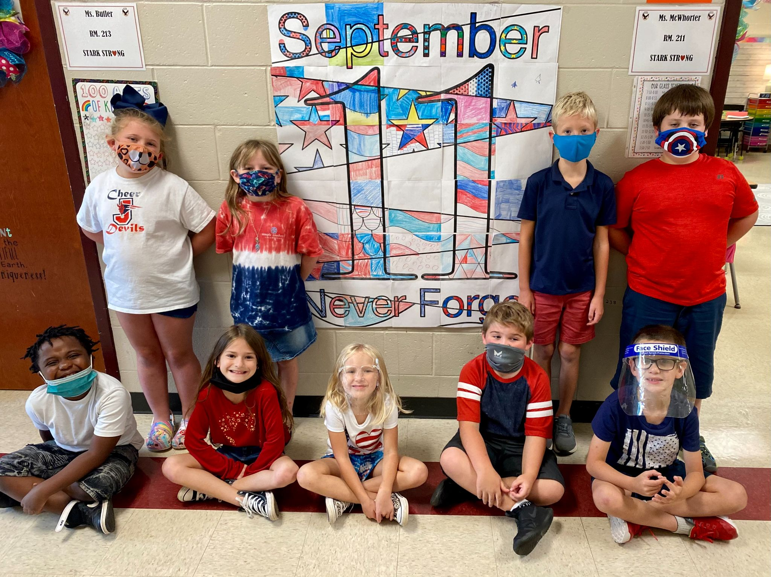 | Sports   By Serenity Hughes  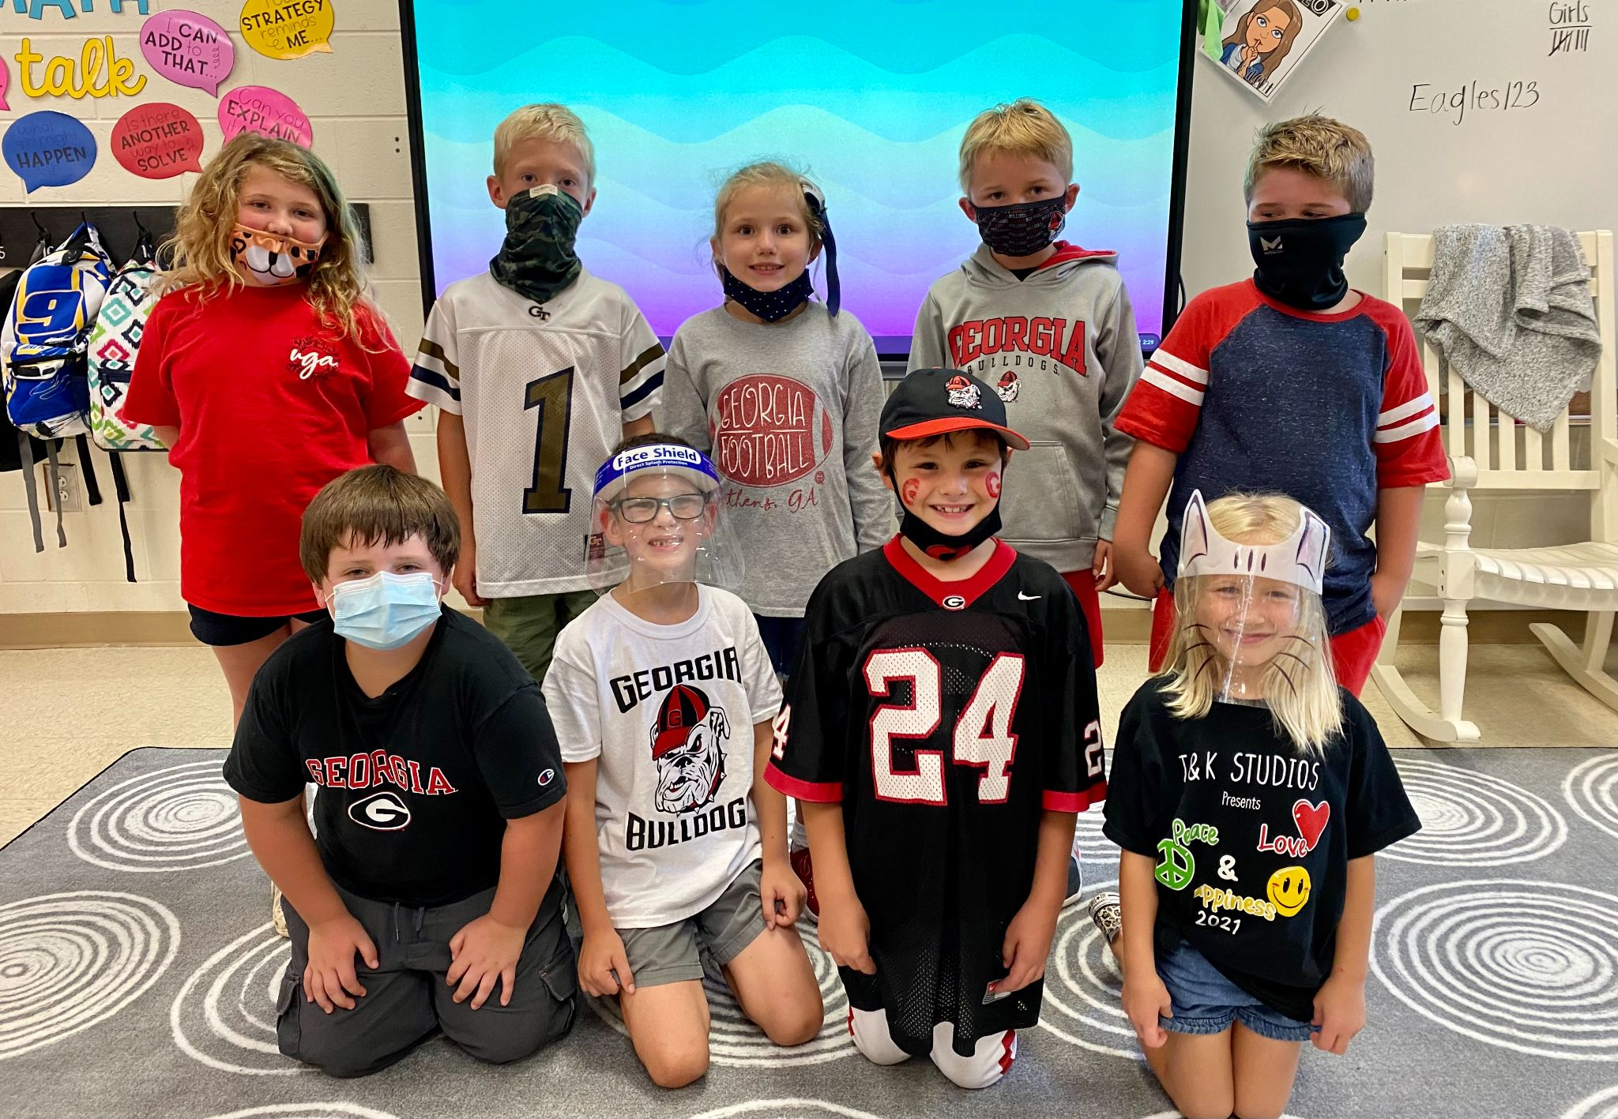  2nd Grade  (Ms. McWhorter’s class)  These 2nd graders were all about the Georgia Bulldogs!!  College game day was Friday, September 3rd here at Stark Elementary. We had staff members and students representing their favorite team! The LSU Tigers and Georgia Bulldogs seemed to be the rivals in the building. We also had a few Alabama fans and a Clemson Tiger or two. The Georgia Bulldogs won against the Clemson Tigers 10-3. The UCLA Bruins beat the LSU Tigers with a final score of 38-27. LSU Tigers fans were very disappointed.  ---------------------------------------------------------  Solve the multi-step problem. Collaborate with a classmate and see if you both share the same answer. 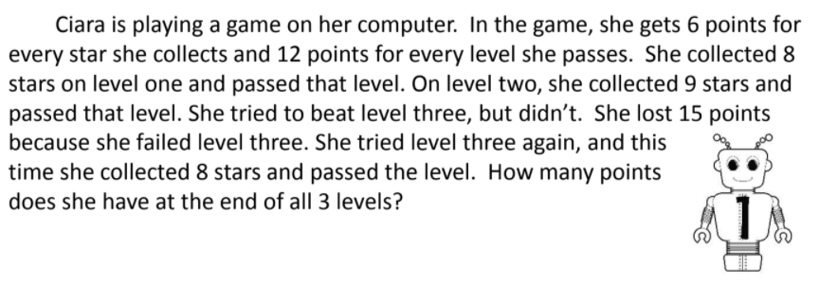  Solve the Riddle  Abigail Holley  Reporter  First tell me the one who lives in disguise. Who deals in secrets and tells nought but lies. Next tell me what's always the last thing to mend, the middle of middle and end of the end. Lastly, tell me the name of the sound often heard during the search for a hard to find word. Now string them together and answer me this. What creature would you be unwilling to kiss? Harry Potter  ----------------------------------------------------------  Clubs & Organizations  Drama Club  Chorus  Robotics  Reading Bowl  Girls on the Move  Boys on the Move  Band  Student Council  4H  CHAMPS

